

St Vincent’s Hospital Sydney (SVHS) eCTN (Clinical Trial Notification)
- INITIAL SUBMISSION -

Instructions:
This form must be completed by the local St Vincent’s Hospital Sydney (SVHS) Principal Investigator for the following studies:
- HREC review has determined that an eCTN submission to the TGA is required
- SVHS is the Australian Sponsor
This form must be submitted as part of the initial site specific application (STE) via REGIS to the Research Governance Officer (RGO) for review.
Once reviewed and accepted by the SVHS RGO for submission to the TGA, the eCTN will be lodged by the SVH Research Office on behalf of the sponsor (SVHS Limited).
The information, as outlined in the table below (page 5 onwards), is required by the TGA.
Further guidance regarding definitions is available via: (https://www.tga.gov.au/completing-online-ctn-form) and (https://www.tga.gov.au/publication/clinical-trial-notification-ctn-form-user-guide).
Prior to the initial submission of the eCTN the SVHS PI must confirm the accuracy of the final eCTN proposal via email to the SVH RGO.
Once the SVHS Research Office submits the initial eCTN proposal on behalf of the sponsor (SVHS Limited) to the TGA for consideration/review and acknowledgement, no further changes can be made.

Unapproved Therapeutic Goods To Be Listed On The eCTN:
It is the responsibility of the SVHS Principal Investigator (PI) to decide if a therapeutic good needs to be included in the CTN.
An 'unapproved' therapeutic good for the purpose of the CTN scheme includes:
- any medicine not included in the Australian Register of Therapeutic Goods (ARTG), such as any new formulation, strength or size, dosage form, name, indications, directions for use or type of container of a medicine already in the ARTG
- any medical device (including an in vitro diagnostic device (IVD)) not included in the ARTG, such as any new sponsor, manufacturer, device nomenclature system code, classification or unique product identifier (for certain classes of medical devices only) of a medical device already in the ARTG
  - any in-house IVD medical device, used for the purpose of a clinical trial, where the laboratory providing the in-house IVD is unable to comply with the regulatory requirements for in-house IVDs
- any biological not included in the ARTG such as:
  - any new applicable standards, intended clinical use or principal manufacturer of a Class 1 or 2 biological already in the ARTG
  - any new product name, dosage form, formulation or composition, therapeutic indication, type of container or principal manufacturer of a Class 3 or 4 biological already in the ARTG
- therapeutic goods already included in the ARTG to be used in a manner not covered by the existing entry in the ARTG.

If the therapeutic good meets the above definition of an unapproved therapeutic good, a CTN must be in place before the product can be supplied for use in a clinical trial.
Placebo is considered to be an ‘unapproved’ therapeutic good and a CTN must be in place before a placebo can be supplied for use in a clinical trial.

Payments:
Once the eCTN has been lodged by the SVHS Research Office, an invoice will be sent via email to the submitter (SVHS Research Office) of the CTN. This invoice will be forwarded to the SVHS PI. It is the responsibility of the SVHS PI to arrange payments of the eCTN lodgement fee. Those fees are set by the TGA and are non-negotiable (https://www.tga.gov.au/book-page/clinical-trials-3).
An invoice must be received from SVHS Research Office before any payments to the TGA as this ensures that there are no delays in matching payments.
Critical Points Regarding eCTN Payments:
- Payments must be made by an SVHS employee from St Vincent’s Hospital Sydney Limited.
- Payments cannot be made by an external institution / organisation / party / university (the TGA will only accept payments directly from the Sponsor - St Vincent’s Hospital Sydney Limited).
- The SVHS Research Office highly recommends that payments are made via Credit Card only (SVHS Trust Fund payments, direct debit and purchase orders cannot be processed by the TGA and invoice payments through the NSW Health finance system can be delayed).
- Prior to lodgement of the eCTN, the SVHS PI must inform us of the appropriate payment method.
- The SVHS PI must email proof of payment to the RGO as soon as the transaction has been completed.

Please note that if the TGA does not receive payment within a reasonable timeframe (usually 2 weeks from the date of the lodgement), the eCTN will automatically be withdrawn by the TGA and a complete new submission will be required.

Commencement of Study:
It is SVHS’s requirement that the eCTN must be formally submitted to the TGA and fully processed before any research related activities can be conducted on site.
Formal Submission & Acknowledgment:
The following steps must be completed before the trial can commence:
- eCTN Submitted: The online eCTN notification is submitted
- Fees paid: Accompanying relevant fees are paid
- eCTN in SVHS Clinical Trials Repository: eCTN notification is available in the SVHS Clinical Trials Repository
- Final Acknowledgement: Final & TGA noted eCTN document is emailed to the SVHS PI
Please note that only the print-outs obtained from the Clinical Trials Repository serve as evidence that the clinical trial has been notified to the TGA.

Variations Post Initial Submission:
Any changes post eCTN submission must be processed as eCTN variations and an additional fee may apply.
Variations must be submitted to the TGA for review if any of the information from the original & final TGA-acknowledged eCTN changes or new information needs to be added (for example but not limited to: change of medicines, site additions, change in personnel, different manufacturers, typographical errors ….)

Completion Notice to TGA:
St Vincent’s Hospital Sydney Limited will notify TGA when a trial is completed using the online CTN form once the clinical trial related activity afforded by this eCTN is complete.
A completion notice is indicated once:
- the last patient completed last visit across all sites
- the trial has been completed at all sites
- HREC approval has acknowledged that all enrolled participants have completed the study
- SVH Governance approval has acknowledged HREC approval and relevant supporting documentation
- all adverse events have been reported in accordance with the trial protocol
It is the responsibility of the SVHS CPI/PI to contact the SVHS Research Office (svhs.research@svha.org.au) when a completion notice is required.

Study Identification
SVHS Reference Number (SVHS)
Project Application number (PID)
Ethics Application number (ETH / other)
Governance Application number (STE)
Name of Approving HREC

Full Project Title
Co-ordinating Principal Investigator:
Site Principal Investigator:
Site: | St Vincent’s Hospital Sydney  St Vincent’s Private Hospital Sydney  The Mater Hospital

eCTN Details

Trial Details:
Protocol Number
Enter the protocol number provided by the sponsor or principal investigator of the clinical trial. This is a unique reference number used to easily identify your trial. This number may be no fewer than 4 and no more than 20 characters.

Expected Trial Start Date
Enter the date you estimate the trial will be initiated at the first Australian site in the format dd/mm/yyyy or select from the pop-up calendar.
The 'expected trial start date' indicated on the CTN form cannot be a retrospective date.

Expected Completion Date
Enter the date you estimate the trial will be completed at all Australian sites in the format dd/mm/yyyy or select from the pop-up calendar.
The ‘expected completion date’ must be a date after the ‘expected trial start date’.

The expected completion date must not be after the current valid HREC expiration date.

Potential use of restricted goods  Select 'Yes' if the trial involves the use of substance(s) that require permission to import under the Customs (Prohibited Imports) Regulations 1956. Otherwise select 'No'. | Yes | ☐
 | No | ☐
Title of Study and Description
Enter the title and description of the clinical trial. This field should include the aim and provide a description of the trial. Include, for example: phase, indication(s) being treated, main investigational product and comparators, use of placebo-control, focus of the study, patient population and any other significant or novel aspects.
Must be a minimum of 250 characters up to a maximum of 2500 characters.

This Trial  Select any check boxes which are relevant to your trial. If you select a checkbox with A - K next to it, you must complete the relevant sub-section (A - K) of the form below.  Please note that SOFTWARE is considered a medical device for the purposes of the Therapeutic Goods Act. | Involves the use of a Medicine (A) | ☐
 | Involves the use of a Medical Device (B) | ☐
 | Involves the use of a Biological (C) | ☐
 | Involves a Genetically Modified Organism (D) | ☐
 | Involves gene therapy (E) | ☐
 | Is placebo controlled (F) | ☐
 | Is comparator controlled (G) | ☐
 | Involves Animal Excipients (H) | ☐
 | Has relevant preceding trials (I) | ☐
 | Is a multicentre trial in Australia (J) | ☐
 | Is being conducted in other countries (K) | ☐
Trial Type  Select the correct check box on the left hand side of the correct trial type(s). More than one check box may be selected.  Medicine or Biological:  • Select the trial phase(s) for the medicine or biologicals under investigation.  Medical Device:  • If the trial is investigating a device, select the Device check box.  Bioavailability/Bioequivalence:  • If the trial is investigating bioavailability or bioequivalence, select the Bioavailability/Bioequivalence check box. | Phase 0 | ☐
 | Phase 1 | ☐
 | Phase 2 | ☐
 | Phase 3 | ☐
 | Phase 4 | ☐
 | Bioequivalence | ☐
Is this a First in Human Trial? | Yes | ☐
Is this a First in Human Trial? | No | ☐
Has this trial, in part or as a whole, been halted/stopped/withdrawn o rejected in another country due to safety concerns? | Yes | ☐
 | No | ☐
Total number of participants to be enrolled in the Trial  Select a range of the estimated total number of participants to be enrolled in the trial in Australia from the list. | 1-20 | ☐
 | 21-50 | ☐
 | 51-200 | ☐
 | 201-500 | ☐
 | 501 + | ☐
Therapeutic Area  Select the therapeutic area for the investigational product from the list. | Cardiovascular System | ☐
 | Central Nervous System | ☐
 | Ear / Nose / Throat | ☐
 | Eye | ☐
 | Gastrointestinal System | ☐
 | Genitourinary System | ☐
 | Immune System / Inflammation | ☐
 | Infections | ☐
 | Multiple indications | ☐
 | Musculoskeletal System | ☐
 | Neoplastic Disorder | ☐
 | Other | ☐
 | Respiratory System | ☐
 | Skin | ☐

Subsections A - K
Involves the Use of a Medicine (A): Yes ☐ No ☐
Each different medicine and each different medicine strength needs separate entries / tables.
Copy and paste (duplicate) this table below as often as needed.

Trade/Product/Code Name
Enter an identifying name(s) of the medicine. If the product has a trade name, product name and code name, enter all three names in the format Trade/Product/Code Name.

Is this a combination product?  Select 'Yes' if the product is comprised of two (or more) active ingredients. Each active ingredient should be entered under ‘Formulation’ (see below). | Yes |  |  | ☐
 | No |  |  | ☐
Is this a cannabis product?  Select ‘Yes’ if the product is medicinal cannabis. | Yes |  |  | ☐
 | No |  |  | ☐
Type of Container
Enter the type of container as defined below.
The container means the vessel, bottle, tube, ampoule, syringe, vial, sachet, strip pack, blister pack, wrapper, cover or other similar article that immediately covers the goods, but does not include an article intended for ingestion.
Examples of type of container include 2mL ampoule, 5mL syringe, blister pack, bottle. The terms Various or N/A are not acceptable.

Dosage Form
Select a dosage form from the list in Appendix A.
Dosage form is the pharmaceutical form in which a product is presented for therapeutic administration, e.g. tablet, cream. See TGA approved terminology for medicines.

Route of Administration
Select a route of administration from the list in Appendix B.
Route of administration means the route by which a therapeutic good is applied on or introduced into the body.

Formulation  Formulation is a list of ingredients used in the manufacture of a dosage form and a statement of the quantity of each ingredient in a defined weight, volume, unit or batch.  An active ingredient is the therapeutically active component in a medicine's final formulation that is responsible for its physiological action. An excipient is any component of a finished dosage form other than an active ingredient.  You must at least enter the active ingredient(s). TGA recommends that you list both the active ingredient(s) and excipient(s) if possible. | Ingredient Name  Enter one ingredient name
Quantity
Enter the numeric part of the ingredient strength/concentration. For example, if the strength of the ingredient is 25 mg, enter 25.

Unit
Select a unit of measurement of the strength/concentration from the drop-down list. For example, if the strength of the ingredient is 25 mg, select milligram.

Indication
Enter the indication the medicine will be used for in the trial.
The indication means the specific therapeutic use(s) of the goods.

Dosage and Frequency
Enter the dosage regimen.
The dosage regimen is the number of doses per given time period, the time that elapses between doses or the quantity of a medicine that is given at each specific time of dosing.

Intended Use  Select if the medicine is a Comparator; Investigational Medicinal Product; or Standard Care Therapy or Other. | Comparator |  |  | ☐
 | Investigational Medicinal Product |  |  | ☐
 | Standard Care Therapy |  |  | ☐
 | Other |  |  | ☐
Is this medicine manufactured in Australia?  Select ‘Yes’ if the medicine is manufactured in Australia. If not, select ‘No’. | Yes |  |  | ☐
 | No |  |  | ☐
GMP licence/clearance number or relevant exemption
- Optional -
Please provide the relevant licence number or exemption if available

Medicine Manufacturer Details | Manufacturer Name
Medicine Manufacturer Details | Manufacturer Address
Please attach the Investigator’s Brochure or equivalent documentation | Title
 | Description

Involves the Use of a Medical Device (B): Yes ☐ No ☐
Each different medical device needs separate entries / tables.
Copy and paste (duplicate) this table below as often as needed.

Product Name
Enter the product or trade name of the medical device.

Is this a  Select the most suitable option | Medical Device (MD) |  |  | ☐
Is this a  Select the most suitable option | In Vitro Diagnostic Medical Device (IVD) |  |  | ☐
Classification  Select Medical Device Classification from the list.  Include the medical device classification (such as Class I, Class III etc. - refer to ‘Medical device overview’). | If MD | AIMD |  | ☐
 | If MD | Class 1 |  | ☐
 | If MD | Class 1 Measurement |  | ☐
 | If MD | Class 1 Sterile |  | ☐
 | If MD | Class II a |  | ☐
 | If MD | Class II b |  | ☐
 | If MD | Class III |  | ☐
 | If IVD | Class 1 |  | ☐
 | If IVD | Class 2 |  | ☐
 | If IVD | Class 3 |  | ☐
 | If IVD | Class 4 |  | ☐
Is this device software or does it incorporate software (this may include firmware)? | Yes |  |  | ☐
 | No |  |  | ☐
Is it an invasive device? | Yes |  |  | ☐
Is it an invasive device? | No |  |  | ☐
Is it an implantable device? | Yes |  |  | ☐
Is it an implantable device? | No |  |  | ☐
GMDN Search Context
To search for a GMDN, select either 'GMDN name' or 'GMDN code'.

GMDN
The Global Medical Device Nomenclature (GMDN) is a collection of internationally recognised terms used to accurately describe and catalogue medical devices, in particular, those products used in the diagnosis, prevention, monitoring, treatment or alleviation of disease or injury in humans.

Description/Intended purpose for Medical Device
Provide a description of the device including details of design, composition, specification, method of use, mode of action and application.

Intended Purpose for Trial  Select the purpose of the medical device in your trial | Comparator |  |  | ☐
 | Investigational product |  |  | ☐
 | Standard care therapy |  |  | ☐
 | Other |  |  | ☐
If 'Other' please provide a description
Please provide a description if 'Other' is selected under 'Intended Purpose'.

Manufacturer details  Please enter the name and address of the manufacturer. Manufacturer is defined under section 41BG of the Therapeutic Goods Act 1989. (see Manufacturer section for more details). | Manufacturer Name
 | Manufacturer Address
Please attach the Investigator’s Brochure or equivalent documentation | Title
 | Description

Involves the use of a Biological (C): Yes ☐ No ☐
Each different Biological and each different biological strength needs separate entries / tables.
Copy and paste (duplicate) this table below as often as needed.

Trade/Product/Code Name
Enter an identifying name(s) of the biological. If the product has a trade name, product name and code name, enter all three names in the format Trade/Product/Code Name.

Is this a combination product?  Select 'Yes' if the product is comprised of two (or more) active ingredients. Each active ingredient should be entered under ‘Formulation’ (see below). | Yes |  |  | ☐
 | No |  |  | ☐
Product Description
Enter a description of the biological under clinical investigation, including a name, biological class (e.g. Class 2 etc.), intended use, indication, details of the design, composition, specifications, mode of action and application, list any associated devices and/or medicines and the method of use of the whole biological product.

Class of Biological  Select a class of Biological from the list. | Class 1 |  |  | ☐
 | Class 2 |  |  | ☐
 | Class 3 |  |  | ☐
 | Class 4 |  |  | ☐
Type of Container
Enter the type of container as defined below.
The container means the vessel, bottle, tube, ampoule, syringe, vial, sachet, strip pack, blister pack, wrapper, cover or other similar article that immediately covers the goods, but does not include an article intended for ingestion.
Examples of type of container include 2mL ampoule, 5mL syringe, blister pack, bottle.

Dosage Form
Select a dosage form from the list in Appendix A.
Dosage form is the pharmaceutical form in which a product is presented for therapeutic administration, e.g. tablet, cream.

Route of Administration
Select a route of administration from the list in Appendix B.
Route of administration means the route by which a therapeutic good is applied on or introduced into the body.

Ingredients  Enter the ingredients used in the manufacture of the biological.  You must at least enter the active ingredient(s). We recommended that you list both the active ingredient(s) and excipient(s) if possible. | Ingredient Name  Enter one ingredient name
Quantity
Enter the numeric part of the ingredient strength/concentration. For example, if the strength of the ingredient is 25 mg, enter 25.

Unit
Select a unit of measurement of the strength/concentration from the drop-down list. For example, if the strength of the ingredient is 25 mg, select milligram.

Country of Origin
Select the country of origin from the drop-down list.
Indication
Enter the indication the biological will be used for in the trial.
The indication means the specific therapeutic use(s) of the goods.

Dosage and Frequency
Enter the dosage regimen.
The dosage regimen is the number of doses per given time period, the time that elapses between doses or the quantity of a biological that is given at each specific time of dosing.

Intended Use  Select if the Biological is a Comparator; Investigational Medicinal Product; Standard Care Therapy or Other. | Comparator |  |  | ☐
 | Investigational Medicinal Product |  |  | ☐
 | Standard Care Therapy |  |  | ☐
 | Other |  |  | ☐
Intended Use ‘other’ Description
Please provide a description if 'Other' is selected under 'Intended Use’.

Is the Biological manufactured in Australia?  Select ‘Yes’ if the Biological is manufactured in Australia. If not, select ‘No’. | Yes |  |  | ☐
 | No |  |  | ☐
Manufacturer details  Please enter the name and address of the manufacturer. | Manufacturer Name
 | Manufacturer Address
GMP licence/clearance number or relevant exemption
Please provide the relevant licence number or exemption if available.
Please attach the Investigator’s Brochure or equivalent documentation | Title
 | Description

Involves a Genetically Modified Organism (D): Yes ☐ No ☐
Enter details of GMOs if any of the therapeutic goods you have listed on the CTN form contain or are produced by GMOs.
Refer to ‘Guidance 21: Medicines produced by genetic manipulation’ and ‘Products regulated as biologicals’ for further guidance regarding the regulation of GMOs.

Involves gene therapy (E): Yes ☐ No ☐
Gene therapy involves the deliberate introduction of genetic material into somatic cells for therapeutic, prophylactic or diagnostic purposes.
Refer to ‘Guidance 21: Medicines produced by genetic manipulation’ for further guidance regarding gene therapy.

Is placebo controlled (F): Yes ☐ No ☐
Each different placebo needs separate entries / tables.
Copy and paste (duplicate) this table below as often as needed.

Product Name
Enter the product name of the placebo.

Route of Administration
Select a route of administration from the list in Appendix B.
Route of administration means the route by which a therapeutic good is applied on or introduced into the body.

Description (including dosage form)
Enter a description of the placebo including dosage form, formulation (ingredients), composition, indications, directions for use, and type of container.

Is comparator controlled (G): Yes ☐ No ☐
Select the check box Is comparator controlled if your study is a comparator controlled trial.
This check box does not open a new sub-form and no additional information is required to be entered at this stage.

Involves Animal Excipients (H): Yes ☐ No ☐
Each different animal excipient needs separate entries / tables.
Copy and paste (duplicate) this table below as often as needed.

Product Name
Enter the name of the product that contains the animal excipient.

Species of Origin
Enter the species of origin. List available online in the TGA Business portal.

Tissue
Enter the tissue from which the animal excipient originated from. List available online in the TGA Business portal.

Preparation
Enter the preparation of the animal excipient. List available online in the TGA Business portal.

Country of Origin
Enter the country of origin of the animal excipient. List available online in the TGA Business portal.

Has relevant preceding trials (I): Yes ☐ No ☐
Relevant preceding trials may include trials involving the same investigational product conducted by the same sponsor or a follow-on trial conducted after a primary/parent study. The relevant preceding trials are populated from the SVH Clinical Trials Repository.

Please provide the eCTN reference number of the preceding trial.

Is a multicentre trial in Australia (J): Yes ☐ No ☐
Select the check box Is a multicentre trial in Australia if the trial is being conducted at more than one clinical trial site in Australia.
This check box does not open a new sub-form and no additional information is required to be entered at this stage.

Is being conducted in other countries (K): Yes ☐ No ☐
Select the check box Is being conducted in other countries if the trial is also being conducted overseas.

Please list all other countries:

All Trial Site Details:
List of All Participating Sites:
Please provide a complete list of all sites to be considered for this eCTN submission in the table below.
Please also add any future potential sites for which HREC approval or Governance approval is outstanding or the collaboration is under discussion.

Site Name | Include into eCTN now  Yes / No | Include into eCTN later  Yes / No
St Vincent’s Public Hospital Sydney
(please remove prepopulated site if this is not applicable)

IF - SVHS Trial Site Information ONLY:
- Site: St Vincent’s Hospital Sydney
- HREC: SVHS HREC
- Only edit the clear/white fields

Site Name  Enter the name of the trial site. | St Vincent’s Hospital Sydney
Physical Location  Enter the physical address (street address) of the trial site, including postcode. A postal address will not be accepted. | 390 Victoria Street, Darlinghurst
State/Territory  Select the state/territory of the trial site from the drop-down list. | NSW | ☒
 | QLD | ☐
 | TAS | ☐
 | SA | ☐
 | VIC | ☐
 | NT | ☐
 | WA | ☐
Expected Site Start Date
Enter the date you estimate the trial will be initiated at this trial site in the format dd/mm/yyyy or select from the pop-up calendar.
This date must fall within the range determined by the 'Expected Trial Start Date' and 'Expected Completion Date' for the form to validate.

Principal Investigator Name
Enter the full name and title of the Principal Investigator at this trial site.

Contact Phone Number
Enter the phone number (including area code) of the Principal Investigator.

Contact Email
Enter the email address of the Principal Investigator.

HREC Name  Enter the name of the Human Research Ethics Committee (HREC) responsible for approving the clinical trial protocol and for monitoring the conduct of the trial. | St Vincent’s Hospital Sydney HREC
HREC Code  Enter the unique HREC Code issued by the National Health and Medical Research Council (NHMRC) for this HREC. A list of HRECs registered with NHMRC (which includes the HREC code) is published on the NHMRC website. The current list is available at Human Research Ethics Committees (HRECs) under ‘Registration’. | EC00140
HREC Contact Officer  Enter the name of a member of the HREC named above. Where possible, this should be the chair or the deputy-chair of the HREC. | Research Office
Position  Enter the position description or title of the HREC contact officer. | Research Office Manager
Contact Phone  Enter the phone number (including area code) of the HREC Contact Officer. | 0283824960
Contact Email  Enter the email address of the HREC Contact Officer. | SVHS.Research@svha.org.au
Name of Approving Authority  Enter the name of the body, organisation or institution that is responsible for approving the conduct of the trial at the particular trial site. | St Vincent’s Hospital Sydney Limited
Approving Authority Contact Officer  Enter the name of the person authorised to represent the body, organisation or institution above. | A/Prof Philip Cunningham
Position  Enter the position description or title of the Approving Authority contact officer. | Interim Executive Director of Research
Contact Phone  Enter the phone number (including area code) of the Approving Authority Contact Officer. | 0283824960
Contact Email  Enter the email address of the Approving Authority Contact Officer. | SVHS.Research@svha.org.au

All Other Participating Trial Site Information:
Each trial site need to be reflected as separate entries / tables.
If the reviewing HREC is SVH HREC, please tick relevant box and leave HREC information blank.
Copy and paste (Duplicate) this table below as often as needed.

Site Name
Enter the name of the trial site.

Physical Location
Enter the physical address (street address) of the trial site, including postcode. A postal address will not be accepted.

State/Territory  Select the state/territory of the trial site from the drop-down list. | NSW |  |  | ☐
 | QLD |  |  | ☐
 | TAS |  |  | ☐
 | SA |  |  | ☐
 | VIC |  |  | ☐
 | NT |  |  | ☐
 | WA |  |  | ☐
Expected Site Start Date
Enter the date you estimate the trial will be initiated at this trial site in the format dd/mm/yyyy or select from the pop-up calendar.
This date must fall within the range determined by the 'Expected Trial Start Date' and 'Expected Completion Date' for the form to validate.

Principal Investigator Name
Enter the full name and title of the Principal Investigator at this trial site.

Contact Phone Number
Enter the phone number (including area code) of the Principal Investigator.

Contact Email
Enter the email address of the Principal Investigator.

HREC Name  Enter the name of the Human Research Ethics Committee (HREC) responsible for approving the clinical trial protocol and for monitoring the conduct of the trial. | SVH HREC ☐  If SVH HREC please tick box | St Vincent’s Hospital Sydney HREC
HREC Code  Enter the unique HREC Code issued by the National Health and Medical Research Council (NHMRC) for this HREC. A list of HRECs registered with NHMRC (which includes the HREC code) is published on the NHMRC website. The current list is available at Human Research Ethics Committees (HRECs) under ‘Registration’. |  | EC00140
HREC Contact Officer  Enter the name of a member of the HREC named above. Where possible, this should be the chair or the deputy-chair of the HREC. |  | Research Office
Position  Enter the position description or title of the HREC contact officer. |  | Research Office Manager
Contact Phone  Enter the phone number (including area code) of the HREC Contact Officer. |  | 0283824960
Contact Email  Enter the email address of the HREC Contact Officer. |  | SVHS.Research@svha.org.au
Name of Approving Authority
Enter the name of the body, organisation or institution that is responsible for approving the conduct of the trial at the particular trial site.

Approving Authority Contact Officer
Enter the name of the person authorised to represent the body, organisation or institution above.

Position
Enter the position description or title of the Approving Authority contact officer.

Contact Phone
Enter the phone number (including area code) of the Approving Authority Contact Officer.

Contact Email
Enter the email address of the Approving Authority Contact Officer.

Appendix A – Dosage Form
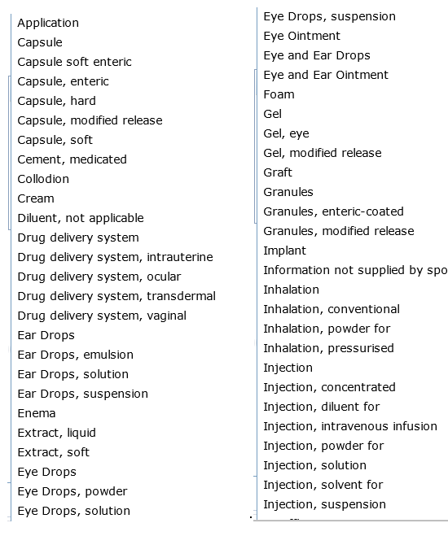
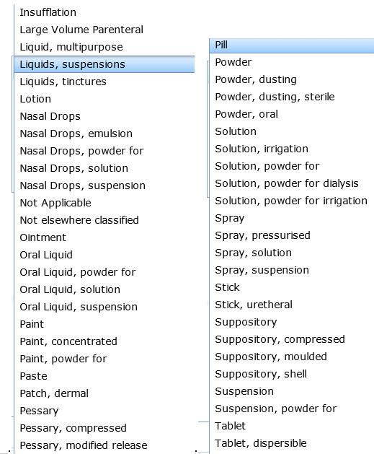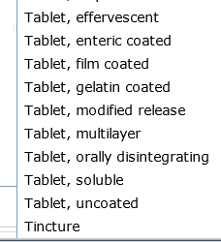

Appendix B – Route of Administration
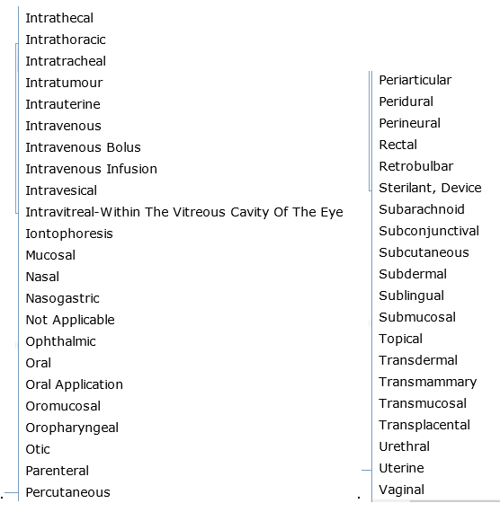
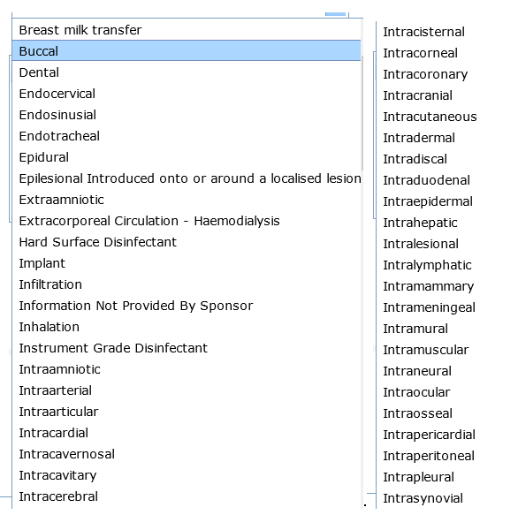

Appendix C
Full text of sponsor declaration:
By clicking the Accept button:

I declare that I am authorised by the sponsor to notify the TGA on its behalf in relation to this clinical trial.

I acknowledge that:

- the sponsor is taking overall responsibility for the trial
- the relevant goods only remain exempt by reason of their use in the clinical trial only for so long as:
  - the approval of the goods for the trial has been given by the sponsor (if the sponsor is conducting the trial), or by the body or organisation conducting the trial for the sponsor, having regard to the advice of the ethics committee responsible for monitoring the conduct of the trial, on terms no less restrictive than terms advised by that committee
  - the sponsor has not received advice from the ethics committee that is inconsistent with the continuation of the trial
  - the requirements in regulation 12AD of the Therapeutic Goods Regulations 1990 (in the case of therapeutic goods other than medical devices) and regulation 7.5 of the Therapeutic Goods (Medical Devices) Regulations 2002 (in the case of medical devices) are complied with, including that the use of therapeutic goods in the trial must be in accordance with the Guidelines for Good Clinical Practice and the National Statement on the Ethical Conduct in Research Involving Humans published by the National Health and Medical Research Council, as defined in the Therapeutic Goods Regulations
  - the Secretary has not under Item 3 of Schedule 5A of the Therapeutic Goods Regulations (in the case of therapeutic goods other than medical devices) or Item 2.3 in Part 2 of Schedule 4 of the Therapeutic Goods (Medical Device) Regulations 2002 directed that the trial not be conducted on the basis that the Secretary has become aware that to conduct the trial would be contrary to the public interest
- the Secretary can under the Therapeutic Goods Act 1989 (the Act), require the sponsor to provide specified information or documents relating to any exempt goods
- the Secretary can provide information obtained in response to an authority or the Commonwealth, or a State or Territory that has functions in relation to therapeutic goods or the registration or medical practitioners or pharmacists in the relevant State or Territory
- it is an offence under the Act to fail to provide that information or documents required by the Secretary, or to provide information or documents that are false or misleading in a material particular, to the Secretary
- it is a requirement of the Guidelines on Good Clinical Practice that the sponsor report all serious and unexpected adverse reactions arising from the use of the relevant goods in the trial to the TGA
- it is a serious offence under Commonwealth law to provide information for the purposes of this notification that is false or misleading in a material particular.

I declare that all information provided for the purposes of the notification is true and accurate and that all required information has been included.

